DATA ANALYTICS WITH POWER BI
PROJECT REPORT
(Project Semester Nov-Dec 2025)

Air Quality Analysis Using Power BI

Submitted by-
Dev Sharma
Registration No. 12316217
Programme: B.Tech CSE
Section: K23BG
Course Code: INT 374



Under the Guidance of
Dr. Vikas Mangotra
UID: 31488
Assistant professor
Discipline of CSE/IT
Lovely School of Computer science and Engineering

Lovely Professional University, Phagwara
DECLARATION

I, Dev Sharma student of Computer science and Engineering under CSE/IT Discipline at, Lovely Professional University, Punjab, hereby declare that all the information furnished in this project report is based on my own intensive work and is genuine.



Date: 08-12-2025 Signature:
Registration No.: 12316217 Name of the student: Dev Sharma

CERTIFICATE

This is to certify that Dev Sharma bearing Registration no. 12316217 has completed INT 374 project titled, “Air Quality Analysis Using Power BI” under my guidance and supervision. To the best of my knowledge, the present work is the result of his original development, effort and study.

Signature and Name of the Supervisor
Designation of the Supervisor
School of Computer science and Engineering
Lovely Professional University
Phagwara, Punjab.

Date: 08-12-2025

Acknowledgement

I would like to express my sincere gratitude to my faculty, Dr. Vikas Mangotra, for her continuous guidance, valuable feedback, and consistent support throughout this project.
I would also like to thank Lovely Professional University for providing the resources and academic environment that allowed me to complete this project successfully.
Last but not least, I extend my thanks to my friends for their encouragement and support during the course of this work.

Dev Sharma

Table of Contents
- Introduction………………………………………………….

- Source of Dataset…………………………………………….

- Dataset Preprocessing
3.1 Handling Missing Values
3.2 Data Cleaning
3.3 Feature Engineering
3.4 Standardization and Data Formatting

- Analysis on Dataset
4.1 AQI Category Distribution
4.2 Pollutant Trend Analysis Over Time
4.3 Seasonal Variation of Pollutants
4.4 Geographic Comparison of Pollutants
4.5 Pollutant Correlation Analysis

- Conclusion……………………………………………………

- Future Scope…………………………………………………

1. Introduction
Air pollution has become one of the most critical global challenges, influencing public health, environmental stability, and urban planning. Understanding how pollutant levels behave across time, seasons, and locations is essential for policy-making and environmental monitoring.
This project aims to conduct a detailed analysis of multi-year air quality data and present insights through an interactive Power BI dashboard. By analyzing pollutant concentrations such as PM2.5, Nitrogen Dioxide (NO2), and Ozone (O3), the project identifies long-term trends, seasonal patterns, high-risk districts, pollutant interdependencies, and overall Air Quality Index (AQI) classifications.
The primary objective of this project is to transform raw environmental data into meaningful insights using structured preprocessing, analytical reasoning, and advanced visualization techniques.

2. Source of Dataset
The dataset used in this project is an open-source Air Quality dataset containing 18,000+ records collected across multiple districts and seasons. It includes details such as:
- Pollutant name and type
- Measurement units and concentration values
- Geographic regions (districts)
- Seasonal and yearly timestamps
- AQI-related indicators
The dataset provides sufficient depth to analyze pollutant behavior across spatial and temporal dimensions.
Project Report

3. Dataset Preprocessing
Preprocessing is a critical step to ensure that the dataset is clean, structured, and ready for visualization. The raw file initially contained inconsistencies in date formatting, redundant columns, missing values, and categorical fields without proper structure.

3.1 Handling Missing Values
- Columns with null values, especially unused metadata fields, were inspected.
- Unnecessary empty fields such as Message and unused identifiers were removed.
- Null entries in Data Value were left as null (ignored during aggregations in Power BI).

3.2 Data Cleaning
- Columns such as Unique ID, Indicator ID, and other redundant fields were removed.
- Text columns including pollutant names, place names, and seasonal labels were trimmed and standardized.
- Date fields were converted into proper datetime format for time-series analysis.

3.3 Feature Engineering
To enable deeper analysis, several new fields were derived:
- Year, Month Number, Month Name — extracted from the timestamp.
- Season — determined based on month grouping:
  - Winter (Dec–Feb)
  - Spring (Mar–May)
  - Summer (Jun–Aug)
  - Autumn (Sep–Nov)
- AQI Category — classified based on pollutant concentration thresholds (Good, Moderate, Unhealthy, etc.).
These engineered features enabled the creation of trend charts, seasonal comparisons, and AQI distribution plots.

3.4 Standardization and Formatting
- Data Value was converted to numeric format.
- Date hierarchy was established (Year → Month → Date).
- Consistent naming conventions were applied to ensure clarity in visualizations.

4. Analysis on Dataset
This section covers the analytical methods used to understand pollution levels across different dimensions. Five major analytical objectives were achieved using interactive Power BI visuals.

4.1 AQI Category Distribution

i. General Description
AQI categories reflect the health impact of air pollution on the population. Understanding how often pollution falls into Good, Moderate, or Unhealthy categories helps identify overall environmental health.

ii. Requirements
- Categorize pollutant readings into AQI segments.
- Analyze the distribution of categories.

iii. Analysis Results
A large proportion of readings fell under Good and Moderate, indicating manageable pollution levels. However, a noticeable percentage belonged to Unhealthy or Very Unhealthy categories, highlighting periodic spikes in pollutant concentration.

iv. Visualization
A donut chart summarizing the share of each AQI category.
Interpretation: While air quality is generally acceptable, certain pollutants frequently breach healthy limits, requiring targeted intervention.

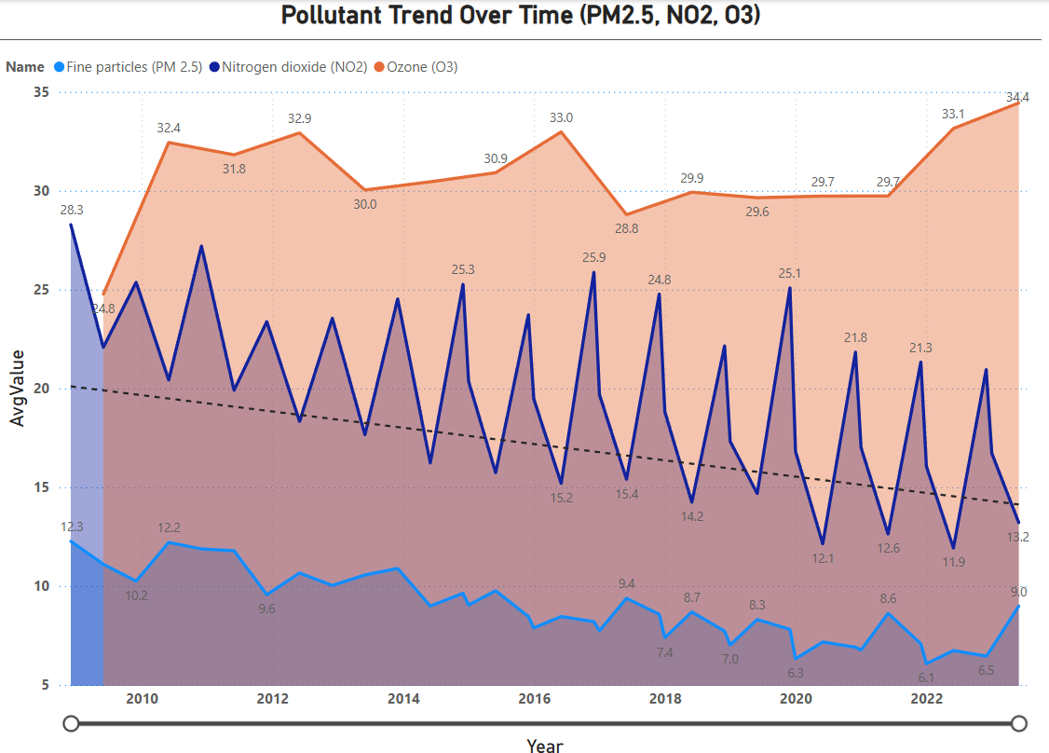

4.2 Pollutant Trend Analysis Over Time

i. General Description
Trend analysis helps identify whether air pollution is improving or worsening over years.

ii. Requirements
- Examine long-term behavioral patterns of PM2.5, NO2, and O3.
- Identify upward or downward trends.

iii. Analysis Results
- NO2 levels showed a clear downward trend, likely due to improvements in vehicular emission standards.
- PM2.5 fluctuated, showing neither a clear improvement nor deterioration.
- Ozone exhibited seasonal oscillations, rising in warmer months.

iv. Visualization
A multi-line time-series chart with trendlines for each pollutant.
Interpretation: NO2 shows meaningful improvement, whereas PM2.5 remains inconsistent and O3 is strongly seasonal.
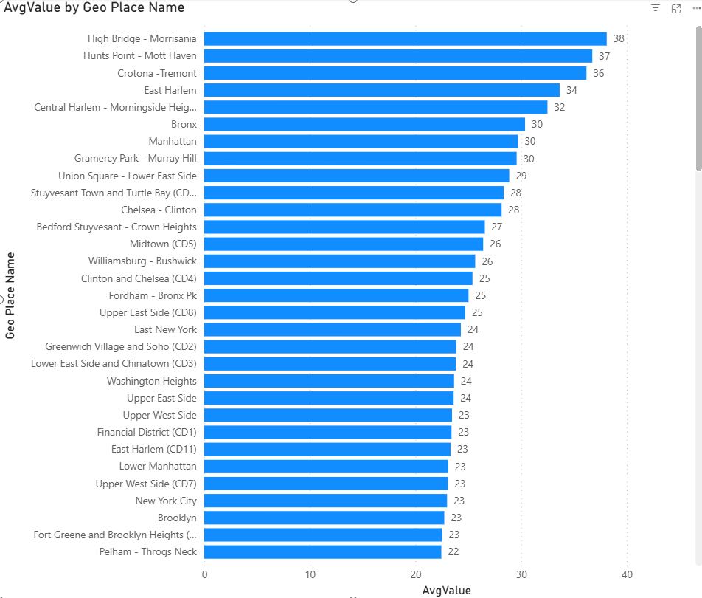

4.3 Seasonal Variation of Pollutants

i. General Description
Different pollutants behave differently across seasons due to changes in temperature, humidity, and atmospheric behavior.

ii. Requirements
- Compare pollutant levels between Summer, Winter, Spring, and Autumn.

iii. Analysis Results
- Ozone peaks during Summer, consistent with photochemical activity.
- NO2 and PM2.5 rise during Winter, driven by heating activities and low atmospheric dispersion.

iv. Visualization
Clustered column chart showing average pollutant concentrations per season.
Interpretation: Seasonality has a strong influence, and different pollutants have different seasonal risk periods.

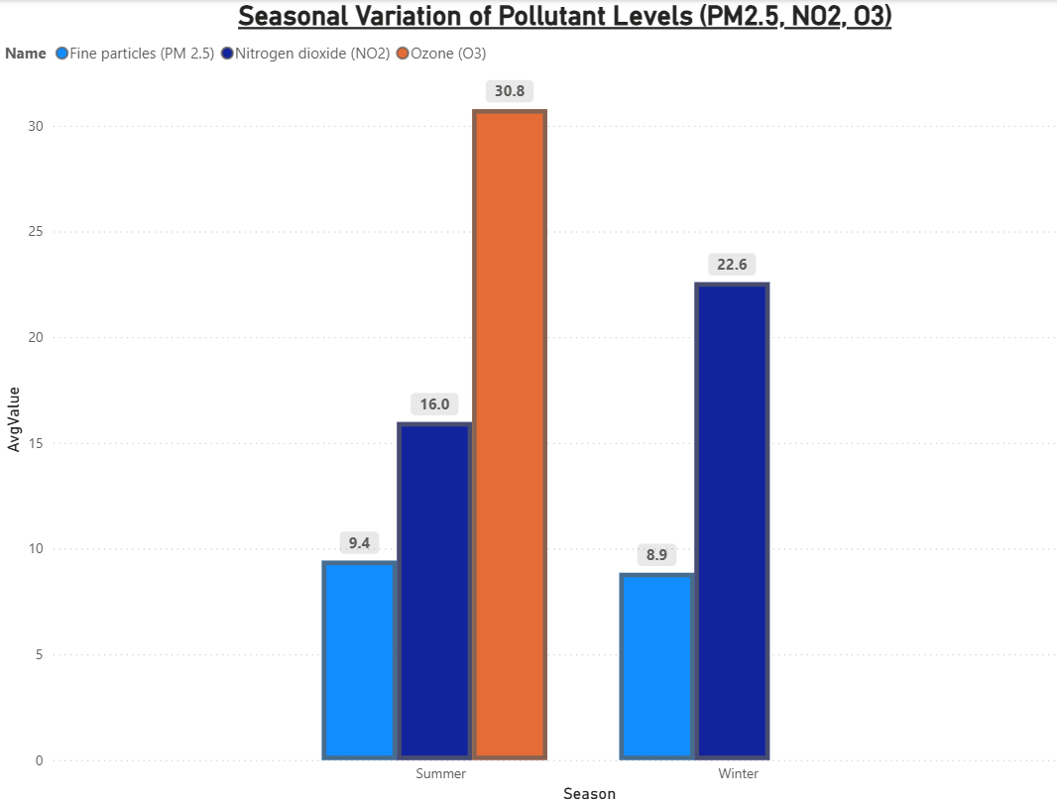

4.4 Geographic Comparison of Pollutants

i. General Description
Pollution distribution varies across districts due to population density, industrial activities, and traffic patterns.

ii. Requirements
- Identify districts with the highest average pollution levels.
- Highlight pollution hotspots.

iii. Analysis Results
- Districts such as High Bridge – Morrisania recorded the highest pollutant averages.
- Several urban clusters consistently appear as high-pollution zones.

iv. Visualization
Horizontal bar chart ranking districts by average pollutant value.
Interpretation: Geographic hotspots help policymakers focus mitigation efforts on identified high-risk regions.

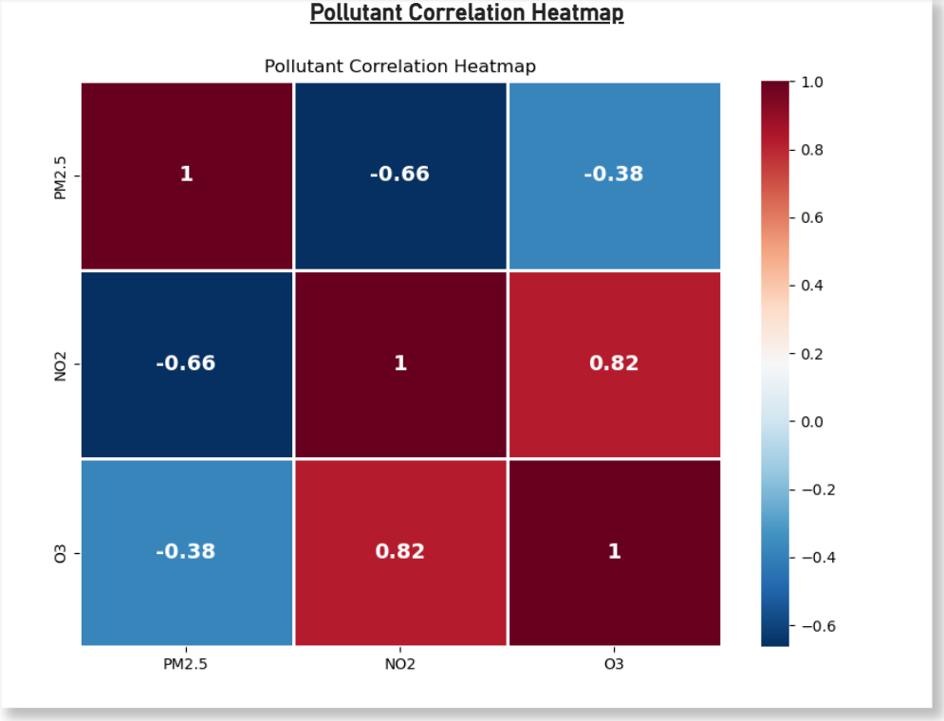

4.5 Pollutant Correlation Analysis

i. General Description
Understanding relationships between pollutants helps identify shared sources or atmospheric interactions.

ii. Requirements
- Measure correlation between PM2.5, NO2, and O3.
- Identify positive or negative relationships.

iii. Analysis Results
- PM2.5 and NO2 show a moderate positive correlation, indicating common emission sources (e.g., traffic).
- O3 exhibits negative correlation with NO2 in some seasons due to photochemical interactions.

iv. Visualization
Heatmap displaying correlation coefficients between pollutants.
Interpretation: Correlation patterns reveal insights into chemical and emission dynamics affecting air quality.

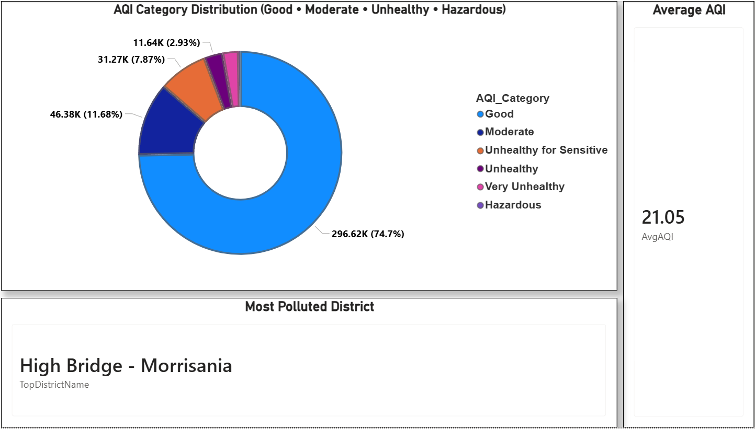

5. Conclusion
This project successfully transformed a raw air quality dataset into an intuitive, insight-rich Power BI dashboard. Through systematic preprocessing, data modeling, and visual analysis, several meaningful patterns were uncovered:
- AQI classification shows generally acceptable air quality but with frequent unhealthy peaks.
- NO2 demonstrates a long-term decline, whereas PM2.5 remains unstable and O3 strongly seasonal.
- Certain districts consistently emerge as pollution hotspots.
- Seasonal and temporal variations reveal clear pollutant behaviors.
- Pollutant correlations indicate overlapping emission sources and atmospheric chemistry.
Overall, the dashboard enables data-driven understanding of environmental health and provides a foundation for decision-making in air quality management.

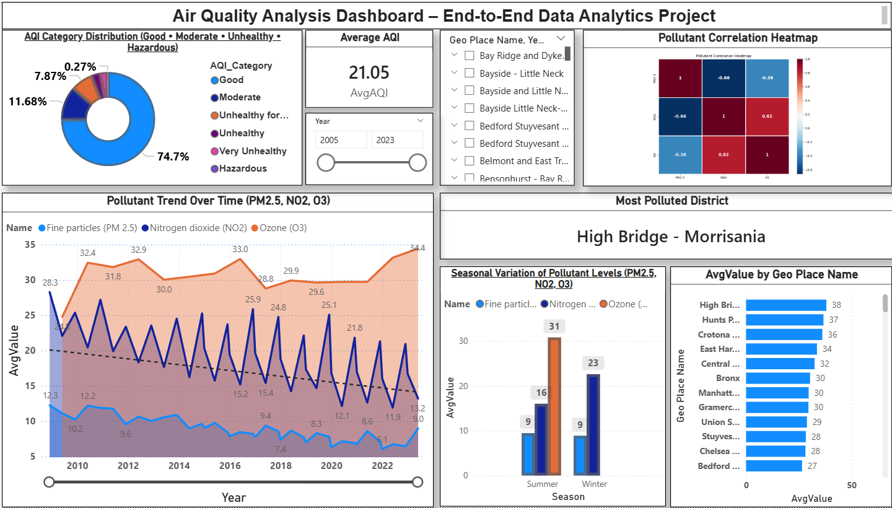

6. Future Scope
The project can be extended further through:
- District-level forecasting using machine learning models.
- Integration of meteorological data (temperature, wind speed, humidity) for deeper analysis.
- Real-time AQI dashboards using live APIs.
- Geospatial pollutant mapping with latitude–longitude coordinates.
- Pollutant-source attribution models to estimate emission contributors.
- Public health correlation analysis linking AQI with respiratory illness data.
These enhancements can significantly elevate the analytical depth and practical applicability of the system.

References

[1] City of New York data.cityofnewyork.us
Dataset Link Available: https://catalog.data.gov/dataset/air-quality

Publish Link:
https://app.powerbi.com/groups/me/reports/10ac6c9d-585f-44cf-a86f-459c2b29f4a5/23fddcf4ab9064700ccb?experience=power-bi

